

Tell us what you think of care services

Who we are


Healthwatch Northumberland
is here to make care better.


We speak up for people who use health and social care services.

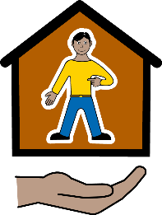
Social care is help to look after yourself.

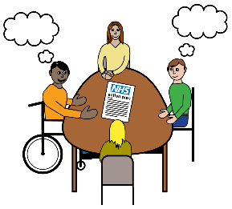
We ask services to listen to your views to make them better.

Tell us what you think of NHS care services

What do you think of the NHS healthcare you have used in the last year?
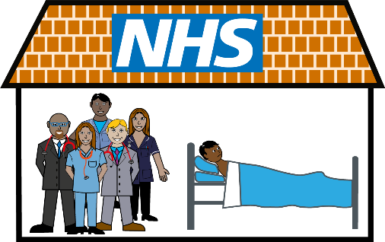
This could be at the doctors or the chemist. It could be at the hospital or at the dentist.



Excellent

Good


Okay


Poor

I have not used any NHS services in the last year

In the last year do you think NHS services have got

A lot better

A bit better

No better or worse. They have stayed the same

A bit worse

A lot worse

I have not used any NHS services in the last year

If you would like to tell us anything about the NHS services you have used please write in the box below.

What you think of Adult Social Care services

What do you think of the Adult Social Care services you have used in the last year?

This could be care given in your home or care homes.

Excellent

Good

Okay

Poor

I have not used any Adult Social Care services in the last year

In the last year do you think Adult Social Care services have got

A lot better

A bit better

No better or worse, they have stayed the same

A bit worse

A lot worse

I have not used Adult Social Care services in the last year

If you would like to tell us anything about the Adult Social Care services you have used please write in the box below.

Help us plan our work

Which ONE of these services do you think we should ask people to tell us about this year? Please tick the box next to the one service you choose.

999 and emergency ambulance

A&E

Adult Social Care

Audiology (hearing) services

Cardiology (heart) services

Care homes

Dentists

Discharge from hospital

GPs and nurses at your surgery

Health Visiting services

Staying in hospital. More options on next page.

Hospital appointments

Maternity (child birth) services

Mental health services

NHS 111

Cancer services

Opticians (eye tests)

Patient Transport Services

Chemists

Physiotherapy

Respite Care

Urgent treatment or walk-in centres

Any other service? Please write below

Please tell us more about you

It would be helpful to know more about you.
You do not have to answer these questions.

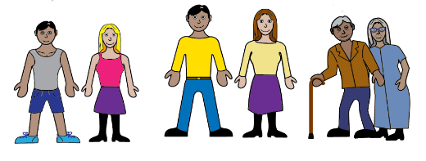

How old are you?

0-12

13-15

16-17

18-24

25-49

50-64

65-79

Over 80

What is your postcode?

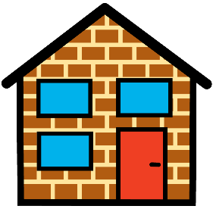

What is your sex?

Female

Male

Other
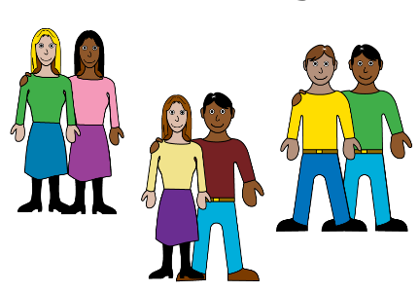
What is your sexual orientation?

Sexual orientation means which
gender you are attracted to. For
example male, female or both.

Asexual. This means you are not attracted to anybody.

Bisexual. This means you are attracted to men and women.

More options on next page.

Heterosexual or straight. This means you are attracted to the opposite gender.

Gay man. This means you are a man who is attracted to other men.

Lesbian or gay woman. This means you are a woman who is attracted to other women.

Pansexual. This means you are attracted to people no matter their gender.

If you would like to use your own word write it below.

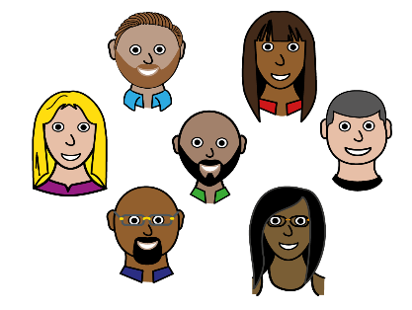
What is your ethnicity?

Ethnicity is your race or background. For example Black, White or Asian.

White: British/English/Northern Irish/Scottish/Welsh

White: Irish

White: Gypsy, Roma, Traveller or Irish Traveller

White: any other background

Arab

Asian/Asian British

Black /Black British

Mixed/Multiple ethnic groups

Any other ethnic group

Are any of these true for you?

I have a disability

I have had a health condition for a long time

I am a carer


How much money do you have?

I have plenty to spend on things I need and plenty left for extras

I have enough to spend on things I need and a small amount for extras

I have enough to spend on things I need and not much else

I don't have enough for things I need and sometimes run out of money

I don't know

Thank you.
Please now send this to us. You don’t need to use a stamp.
Our address is:
Healthwatch Northumberland
FREEPOST
Adapt (NE)
Burn Lane
Hexham
NE46 3HN
For more information

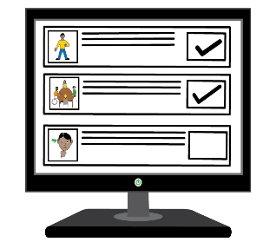
You can look at our website which is
healthwatchnorthumberland.co.uk

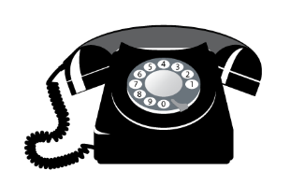
You can contact us by phone.
Call 03332 408468.

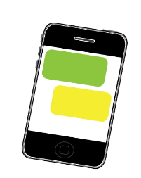

You can text us on 07413 385275.
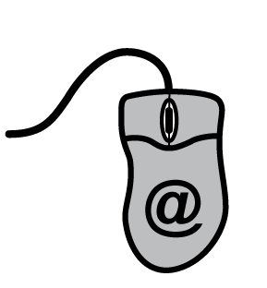
You can email us at
info@healthwatchnorthumberland.co.uk

