North East and North Cumbria Healthwatch:

GP Access, Pharmacy First and NHS App Survey 2025

We want to hear from you.
This survey is about three NHS services that help people get
care more easily.
These are
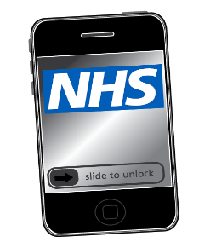
The NHS App

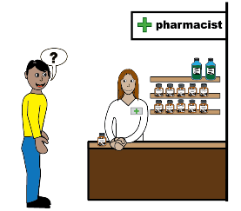
Pharmacy First
 GP Extended Access
Your answers will help us understand what works well
and what needs to be better.
Please answer the questions below.
You can ask someone to help you.

1. Have you used the NHS App?
Yes
No
If yes, what did you use it for? Please write in the box below.

Was it easy to use? Please write in the box below what was easy about using the NHS App.

What is Pharmacy First?

Your pharmacist can now give you treatment for seven common conditions without you needing to see your doctor. These are

Earache

Impetigo

Infected insect bites

Shingles

Sinusitis

Sore throat

Urinary tract infections for women aged 16 – 64

2. Have you used Pharmacy First?
Yes
No

What did you think about the service? Please write in the box below.

What is GP Extended Access?

You can now see a doctor or nurse at your GP surgery outside of usual hours. This could be in the evenings, early mornings or at weekends.

3. Have you used GP Extended Access?
Yes
No
Did it help you get care when you needed it? Please write below.

4. Is there anything else you want to tell us about the NHS App, Pharmacy First or GP Extended Access? Please write in the box below.
Thank you!
Your answers will help improve NHS services for everyone.
If you have more time please tell us a bit about you.

What is your age?
13-17

18–24

25-34

35-44

45-54

55-64

65-74

75+

Do you have a disability?
Yes
No

Which town or city do you live in? Please write in the box below.

Please return this form to:
FREEPOST Healthwatch Northumberland
Adapt (NE)
Burn Lane
Hexham
Northumberland NE46 3HN

You do not need a stamp.

